**Project Documentation (Knative with Jenkins)**

**Phase 1:**

**NOTE:** Ensure you have GitHUb account with proper repository created before you start this task. And also I am preparing my dev environment first with one application (coit-frontend)

**Clone and publish the code from local git to remote repository GitHub:**

**Git Setup: Follow below link to install Git client on your machine.**

[Git - Downloads (git-scm.com)](https://git-scm.com/downloads)

Create an empty folder with name Development

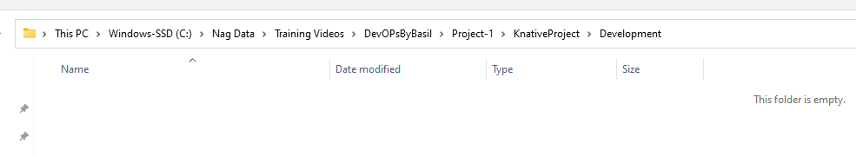

Clone coit-simple-microservice to this empty directory by using GitBash terminal that you get once you installed Git client on your machine,

**git clone** [**https://github.com/Coit-IO/coit-simple-microservice.git**](https://github.com/Coit-IO/coit-simple-microservice.git)

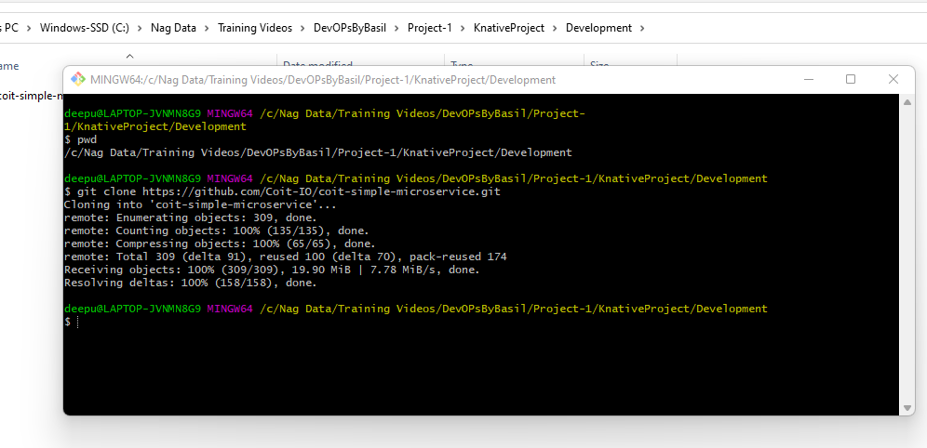

**Go to “coit-simple-microservice” directory and remove .git folder to create your own local repository and commits.**

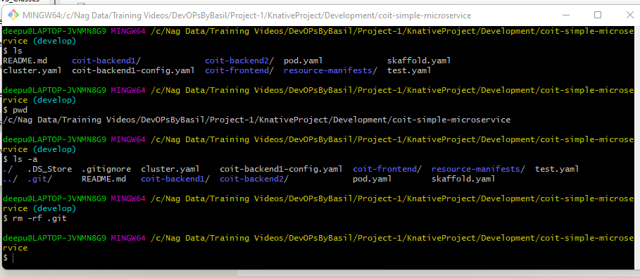

**Run “git init” command to make current local directory to working directory.**

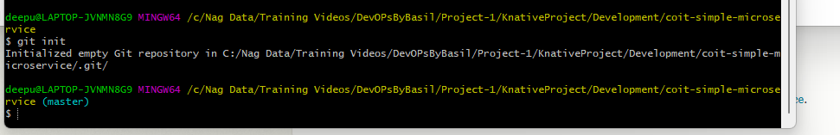

**By default it’s a Master branch and we can commit all our code changes to local master branch by running below commands**

**Git status**

**Git add .**

**Git commit -m “Dev First Commit”**

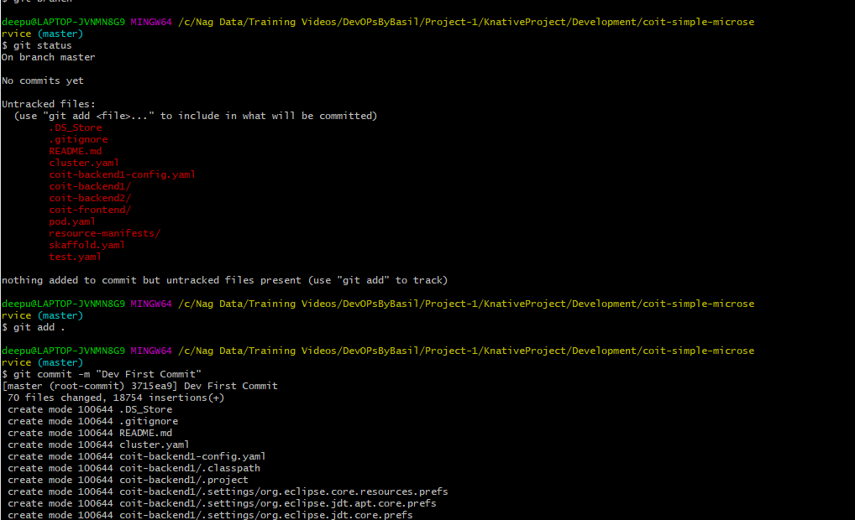

**Since my main module code is committed to local repository, I will create a separate branch for Development env work.**

**Use below command to create a sub branch with name “dev’**

**Git branch “dev”**

**To see list of branches use below command**

**Git branch**

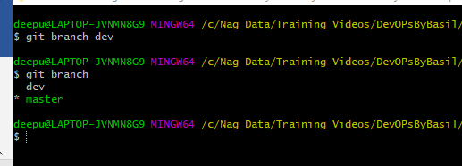

**Now check out to dev branch by using below command**

**Git checkout dev**

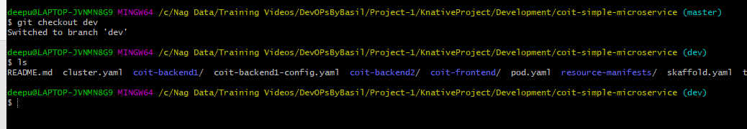

**Here is I want make all modification to my original code as per Development environment requirement like** scale down to zero enabled, and also the maximum number of replicas each application can have will be 5 in production and point github & docker registry images to my own repositories.

Below is the sample code for one of frontend app.

Two yaml files ( one is for setting up max 5 replicas

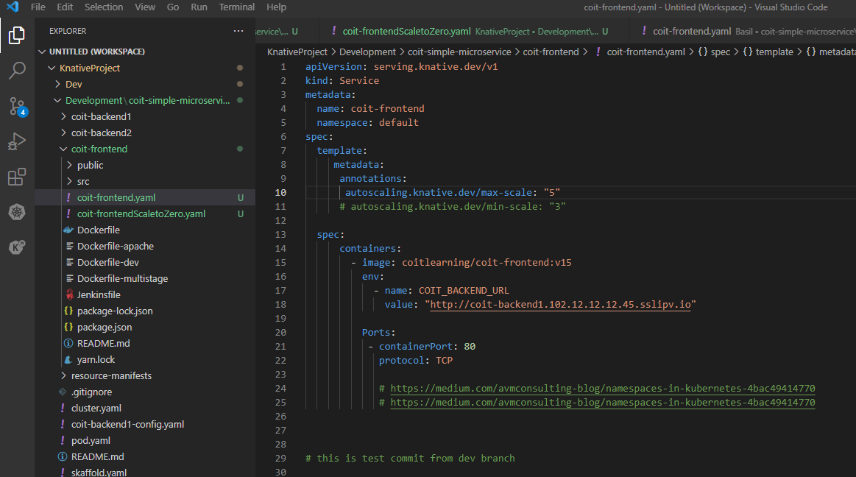

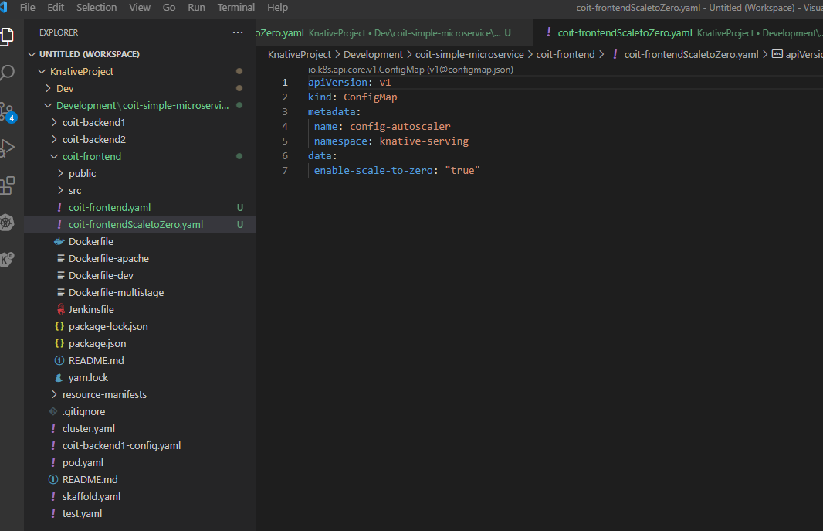

**As my required my Kubernetes manifest files are ready with my requirement I can commit these changes to local Dev branch working repository and merge with master branch then push it to my Github remote repository.**

**Below are the command I used to perform above all tasks.**

**Git status**

**Git add .**

**Git commit -m “dev changes -1”**

**Git checkout master**

**Git merge dev**

**git config --global user.name "Nag"**

**git config --global user.email "chittiinfo@gmail.com"**

**git remote add origin https://github.com/Chittiinfo/knative.git**

**git push origin master**

**you can see my code is now pushed into my remote repository chittiinfo/knative.**

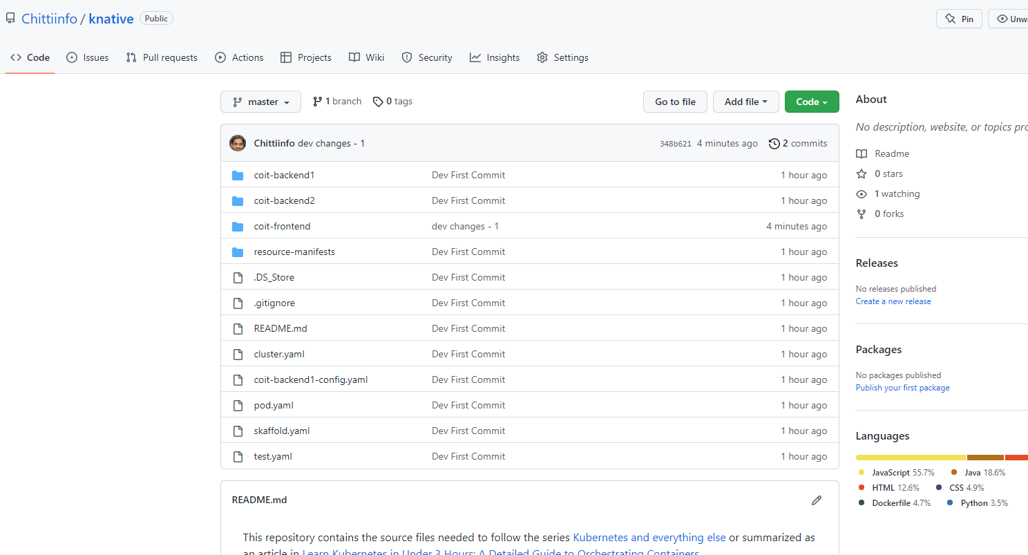

**Next steps to build Jenkins sever and build pipeline to publish app in K8s cluster…… going to work on this**